Nguyễn Thụy Vy – 13521064

This program is developed on Visual Studio 2013 Ultimate.

From Update 3:

*Note: Some old features (such as Rotate, Move, etc) can be found in Edit menu, just hover the Edit menu. Ways to use them are the same as before.*

**Scrollbar**

If you used the old scrollbar, you may have met this mistake:

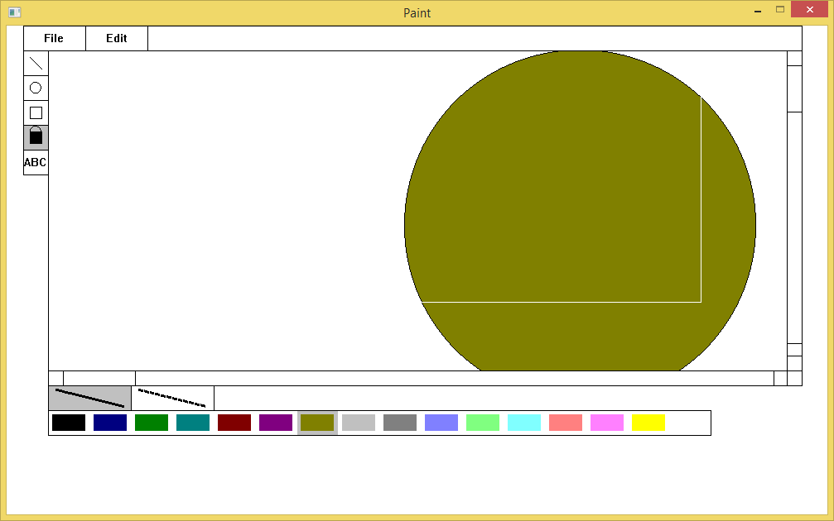

It is fixed now!

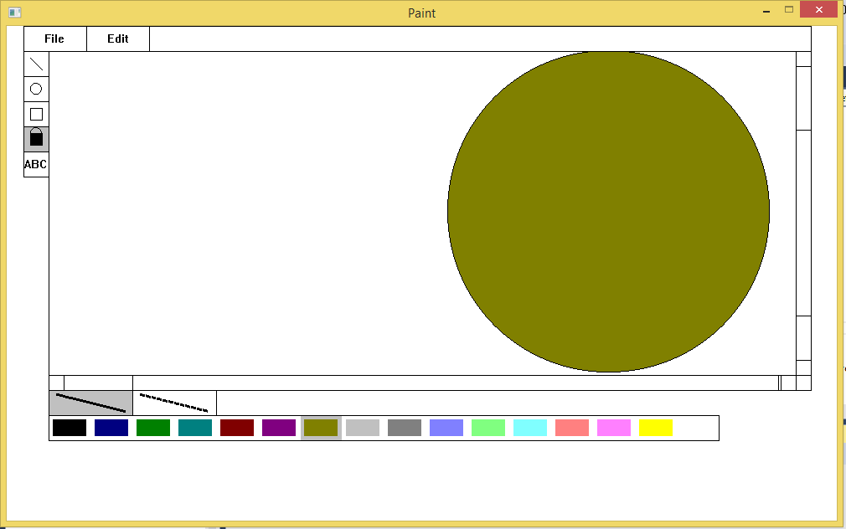

By the way, if you click on scrollbar, all the layers will be merged.

**New**

Now if you are bored with old drawing, you are now able to enter new blank drawing with no need to restart the program. Some option button on the Tool Panel may be still active but functionless. ~~It is an intentional bug.~~

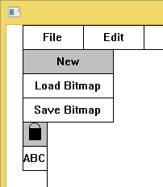

**Move**

Now you can move your old drawing by clicking on E:\Untitled-1.png button, then clicking on one of your drawing (if it is one of the top layers) and dragging it. This function ***does not work*** with ***FILL*** and ***Scrollbar*** and ***KEY-input*** graph and may be cracked somewhere. Do not worry, it is definitely intentional bug and it will never be fixed unless you give me more grades. No, I am just joking, you don’t need to take off my grades, please.

**Undo**

Once you click on Undo option, all the layers will be merged.

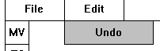

**S for Superman**

Click on E:\Untitled-3.png on Tool Panel and then click on an available graph on drawing area to stretch the graph along x-axis or along y-axis. You are also able to reflect the graph through x-axis or y-axis by typing in negative numbers (The “x-axis” and “y-axis” that I mention here is flexible to each graph. I believe that no common user would care what so called “x-axis” and “y-axis” are.)

Example:

X ratio = -1 Y ratio = 1 🡺 x-axis reflection.

X ratio = 1 Y ratio = -1 🡺 y-axis reflection.

X ratio = -1 Y ratio = -1 🡺 x-axis reflection & y axis reflection.

X ratio = -0.5 Y ratio = -3 🡺 x-axis reflection & y axis reflection & half width & triple height.

Literally, it can work with any well-defined graph. The circle and any graph comprising curve relation may not be stretched or reflected well due to my bad-defined graph. Eclipse angle relation should fix these problems but I am too bored to realize the idea.

This tool ***does not work*** with ***FILL*** and ***Scrollbar*** and ***KEY-input*** graph and may be cracked somewhere.

Have fun.

**Crop**

Click on E:\Untitled-1.png and then click and drag on drawing area to choose an area to crop. When you are satisfied with your chosen area, you can release your mouse to crop.

This tool ***does not work*** with ***FILL*** and ***Scrollbar*** and ***KEY-input*** graph and may be cracked somewhere.

**R for… whatever**

Click on E:\Untitled-1.png then click on an available graph, type in your rotation degree and press “Enter”, a graph rotation will take place. Life is complete.

This tool ***does not work*** with ***FILL*** and ***Scrollbar*** and ***KEY-input*** graph and may be cracked somewhere.

Any graph comprising curve relation may not be rotated well.

**SH for… HandSome**

Sorry, life is not complete yet. Click on “SH” button then click on an available graph, type in your X shear and Y shear, a graph shearing will take place. Life is now indeed complete.

This tool ***does not work*** with ***FILL*** and ***Scrollbar*** and ***KEY-input*** graph and may be cracked somewhere.

Any graph comprising curve relation may not be sheared well.